We are a Private Limited company – CHANCE Recruitment Ltd, registered number SC749909 - engaged in providing recruitment services. This Policy has been developed in proportion to and taking into account the nature and type of our business undertakings, company size and geographical area in which we operate our services.

We are committed to conducting our business in a way that presents no risk of injury or ill health to our employees, suppliers, contractors, visitors or customers as a result of accidents or dangerous occurrences in the workplace. Achieving this is a process of improvement and relies primarily on the systematic identification, assessment and control of hazards and risks, underpinned by awareness of the relevant legislative requirements. Additionally, we conduct regular inspections and thorough investigation of incidents.

We are committed to a continuous review and improvement of our management of health and safety taking into account new legislation and changes in workplace practices.

Our Health & Safety policy requires the involvement and commitment of everybody in the business. Our management and senior staff members take responsibility to ensure the implementation and maintenance of health and safety controls and procedures.

We are committed to making available adequate resources to fulfil this policy and ensuring that staff are consulted and involved at every relevant stage. We ask that everybody in the company works in a way which presents no risk to themselves or others and meets our expectations. We endeavour to employ competent personnel and ensure they are provided with sufficient information, instruction and training to carry out their work activities and responsibilities.

Every employee of the company has a legal obligation to co-operate in the day-to-day implementation of this policy and to take reasonable care for their own health and safety and the safety of other people who may be affected by their acts or omissions

Signed: | 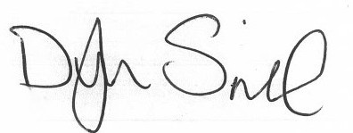 |  | Signed: | 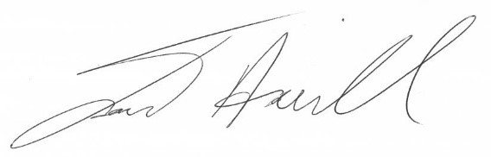
Name: | Dylan Spink |  | Name: | Jack Howell
Date: | 05/09/2025 |  | Date: | 05/09/2025
Position: | Director |  | Position: | Director

